2024 W2 Guide

To provide greater functionality and more value to our customers MIP FUND ACCOUNTING has partnered with Aatrix® to handle all W2 processing and filing. You have the option to electronically file both federal and state W2 filings as well as print and file. This document covers how to produce your W2’s through MIP FUND ACCOUNTING/Aatrix®.

IMPORTANT NOTES

Efiling Thresholds for 2024 Tax forms are 10 combined forms.
If you have more than 10 forms combined (1099/W2 etc) you will be required to efile the Federal copy. There is not charge to efile the Federal Copy.
https://www.irs.gov/forms-pubs/new-electronic-filing-requirements-for-forms-w-2

You should be on Version 24.x or later to process your tax forms.

You will need to be on 25.1 to get the 2025 Tax Tables.
25.1 will be released January 2025.
You can still run payroll without the updated tax tables without issue.
See KB 27801 for details
https://kb.communitybrands.com/article/processing-federal-and-state-taxes-income-taxes-without-tax-update

All printing and filing of W2s in MIP FUND ACCOUNTING is done through Aatrix®.
See the Quick Start Guide on the next page for simplified instructions.

Pre-printed forms are not required and will not work with Aatrix®.
You will need blank perforated forms. See Section 5 for the proper forms. Better yet use the complete filing option to save time and money.

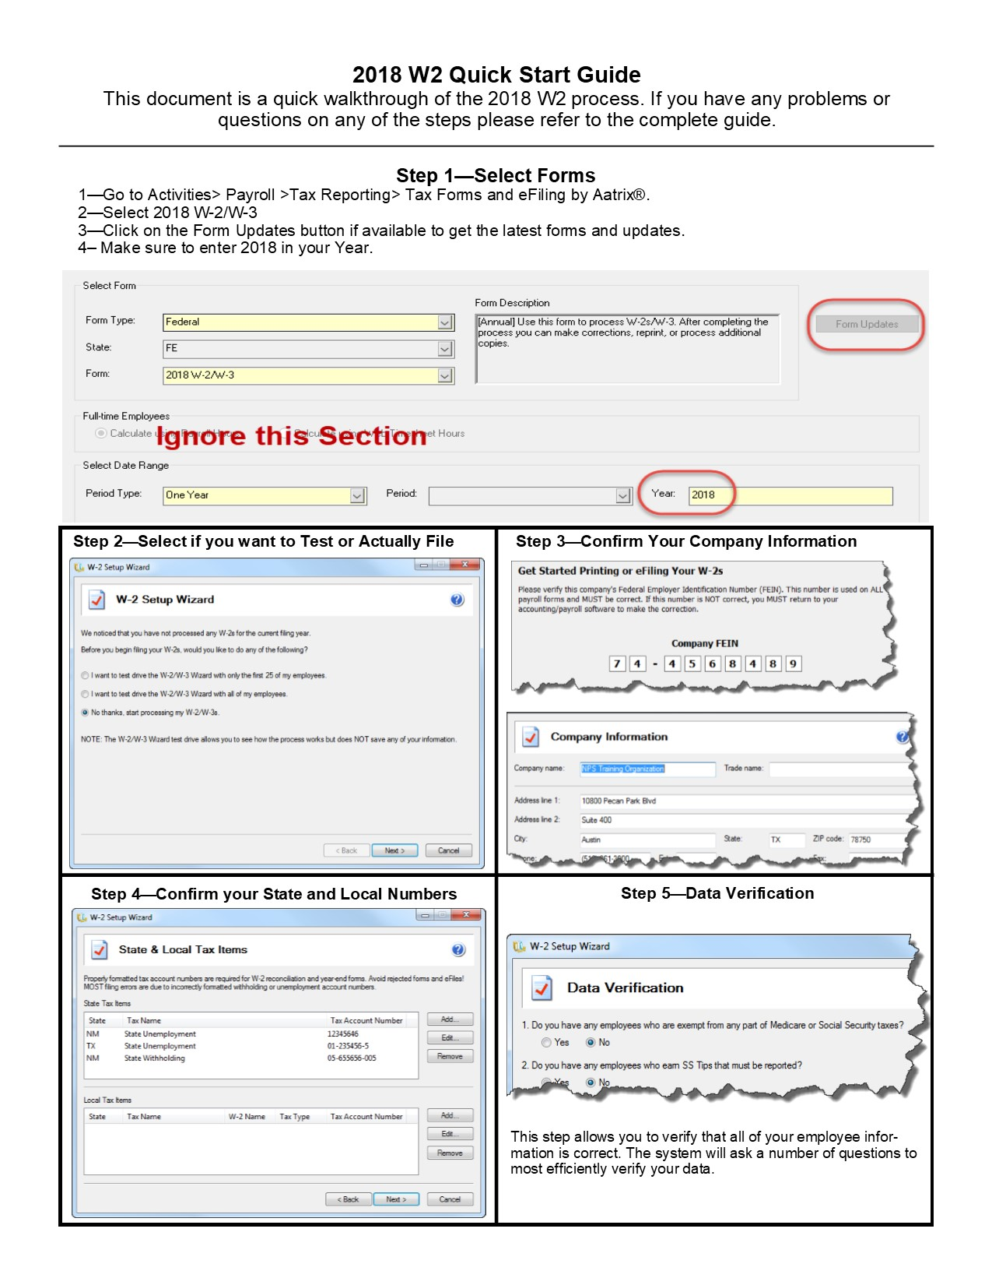
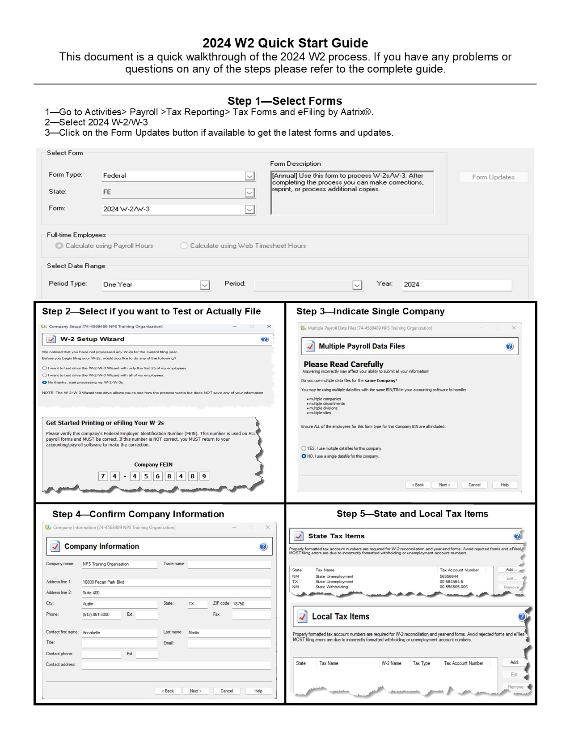
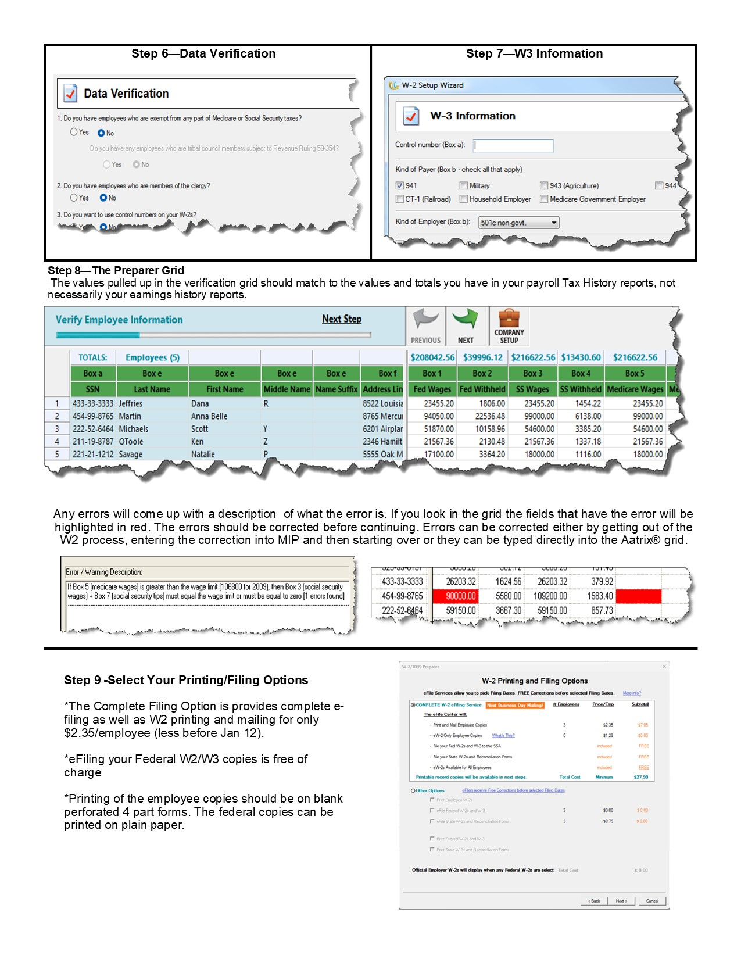
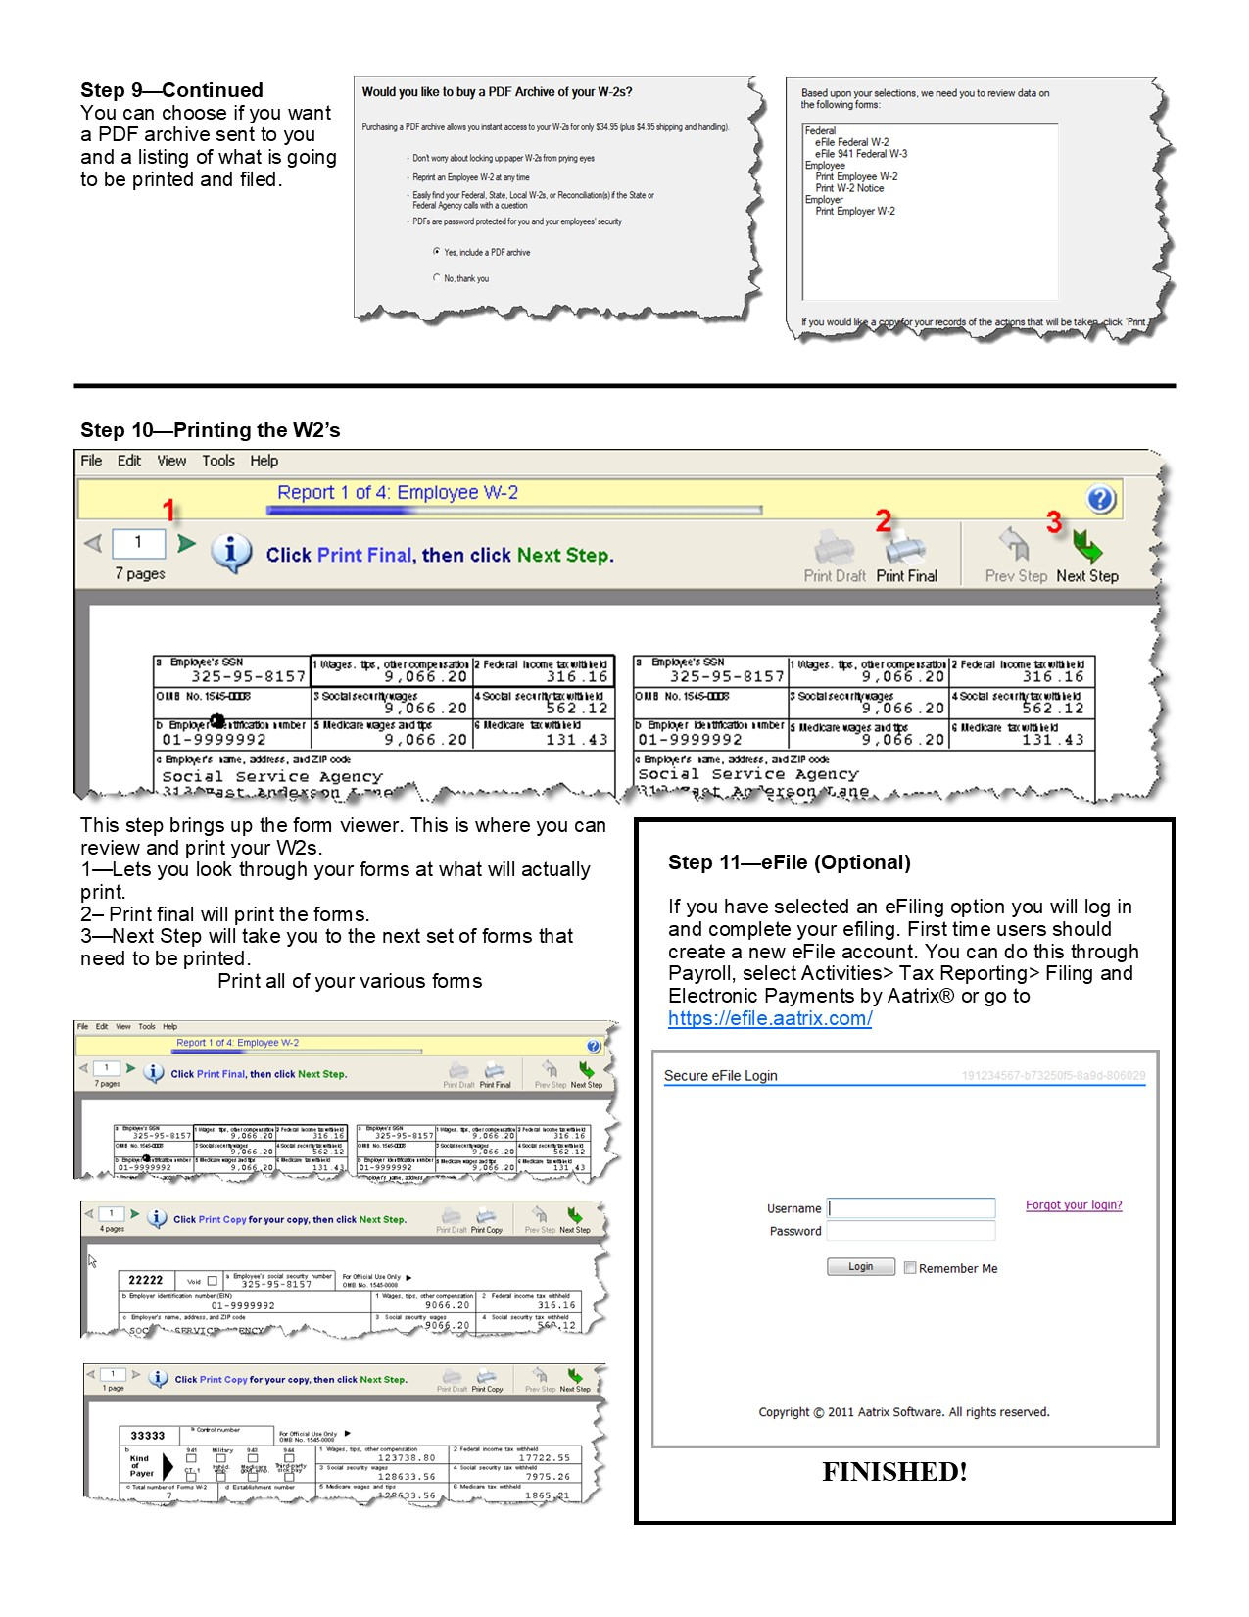
Table of Contents
Table of Contents 1
Introduction 6
Section 1 – Producing W2s 7
Select From Screen 7
Processing 8
Multiple Payroll Data Files 9
Data Verification 11
Section 2 – The W2 Preparer Grid 13
The W2 Preparer Grid 13
Making corrections 14
Correcting the Error through MIP FUND ACCOUNTING: 14
Correcting the error through Aatrix®: 14
Section 3 - Filing and Printing 15
Complete W2 eFiling. 15
eW-2 Only Employee Copies 16
eFile Federal W2 & W3 16
eFile State W2 and Reconciliation Forms 16
Printing Options 16
Section 4 - W2 Form Viewer 18
eFiling 20
Section 5 - Required Forms 21
Section 6 - Corrections, W2C’s and Additional filings 22
How to Process Additional New Filings 24
How to Reprint Completed W2s 25
Correcting W2s 27
W2C 29
Starting Over 29
Section 7 - Adding State and Localities to your W2 30
Section 8 – Electronic Distribution of W2 34
Section 9 - Advanced Grid Operations 36
Sorting 37
Inserting a Row 37
Section 10: Auditing and Correcting Your W2’s 39
Auditing Boxes 1-6 39
Auditing Boxes 15-20 40
Auditing Boxes 12 and 14 40
Health Insurance Reporting Requirements 41

Introduction

What is Aatrix®?

Aatrix® is a leading provider of online filing and compliance for payroll and tax forms. MIP FUND ACCOUNTING has integrated the functionality of Aatrix® to provide support for additional forms and services and simplify the filing process for our customers. The advantage of using Aatrix® for filing W2s means that you can now:

- Print W2s on plain perforated paper (or even blank paper) without having to purchase pre-printed forms
- Print and file W3s and other supporting forms
- Electronically file Federal W2s for free
- Electronically file State W2s for a modest price.
- Have Aatrix® handle all of your printing, stuffing, mailing and filing with their complete service option.
- Print and file many State Tax Forms.

All W2 filing is done through Aatrix®.

NOTE: The screenshots and documentation in this document may vary from what you see due to updates.

Section 1 – Producing W2s

To begin the W2 process go to Payroll>Activities>Tax Reporting>Tax Forms and eFiling by Aatrix®.

If this menu option does not appear in the dropdown menu, you have not been granted rights to produce W2s. You will need to have rights granted to you. For instructions on how to do this see KB 951.

Select From Screen
This menu selection will bring up the Aatrix® selection box. This will allow you to make selections for the form you want to process.

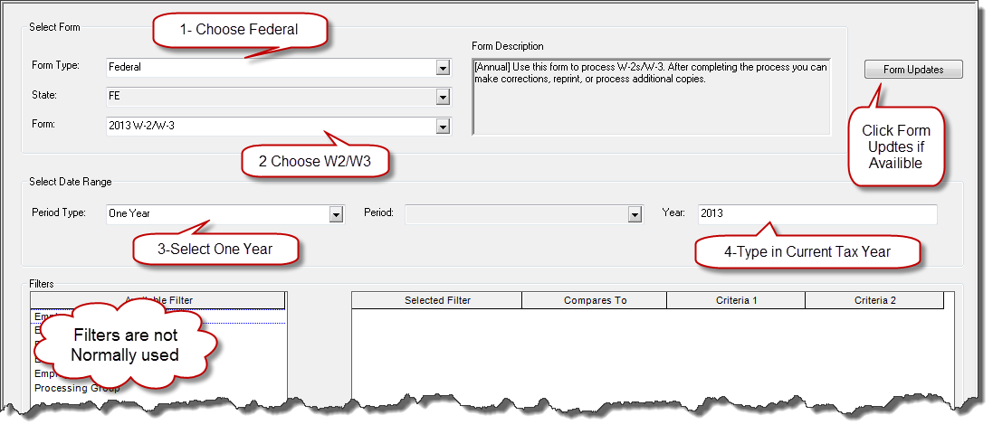

1. Form Type
To produce W2s you will want to choose Federal.

2. Form
For W2s select 2024 W-2/W-3. This selection will not be available until around December 20th, 2024. If you do not see the form click the Form Updates Button if it is available. This will load the latest forms from Aatrix®. If you don’t see a form in the drop-down list after installing the most recent update try logging out and logging back in again.

3. Date Range
This should be One Year.

4. Year
It is possible to mix and match the form year and the year it calculates the data for, so be sure that if you are printing on a 2024 form that you choose 2024 as the year.

5. Filter
The filter allows you to limit the data that is processed in Aatrix®. Some companies only need to produce forms for a subset of their employees. You can accomplish this by using the filter. Aatrix® will only calculate and produce forms for the information that you have selected.

NOTE: If you filter on a set of employees and then go back to run your W2’s again it will automatically use the same set of employees. To use a different set (or all employees) you must disregard history and start over.

Form Updates

The Form Updates feature will automatically check to make sure you have the latest updates from Aatrix®. The Form Updates button is only available if there is an update from Aatrix®. It is recommended that you download updates whenever they are available.

Note: Customers in the Multitenant Cloud will not see the Form Update button. All updates are done automatically.

Processing
Test Drive
After you have made your selections on the form click OK and launch the W-2 Wizard. The first screen will give you options for running through the process in test mode.

If you have not used Aatrix® before, going through the process in test mode is a good idea.

This can be helpful for detecting any problems or corrections that need to be made to the data. NOTE: Any changes you make here WILL NOT be saved or carry forward onto your W2’s.

If you choose to test drive Aatrix® it will go through the entire process. If you choose to efile it will even prompt you to log in and submit the file and give you a filing number. Any printouts that you make in test mode will have a do not file watermark on them.

This is a good way to go through the entire Aatrix® process and make sure that everything is working properly.

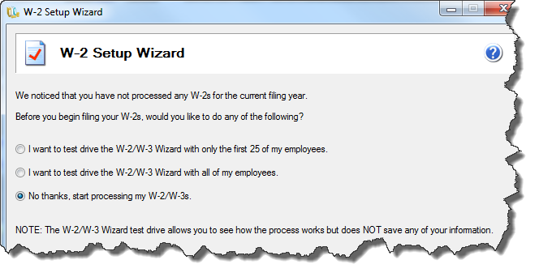

The next screen of the wizard asks you to confirm your company FEIN. If this number is not correct it cannot be changed in the wizard. You must exit the wizard and go into Organization>Organization Information and update your Federal Tax ID number there, then log out and back into MIP and restart the Aatrix® process.

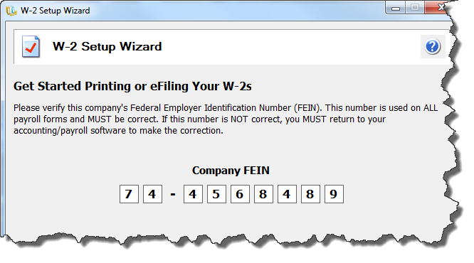

Multiple Payroll Data Files

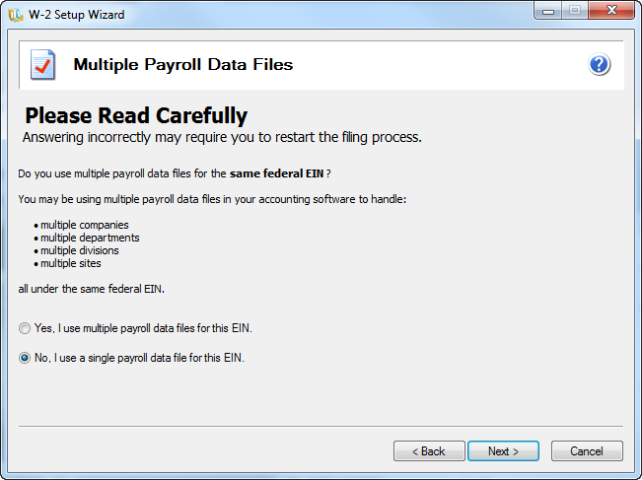

You will be asked if you want to use multiple payroll data files for the same EIN. In most cases you should click no. If you are using multiple databases with the same EIN see KB 8061. If you are using multiple EIN numbers in the same database see KB 12791.

The next screen pulls in your company information.
This information should pull from what you have recorded in the Administration module. You can edit or update any incorrect or missing information in this screen.

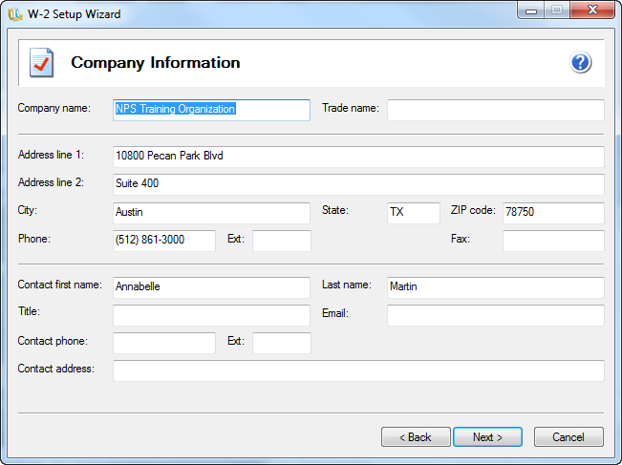

If this information is incorrect or changes after you have started the Aatrix® process it can be updated on the Aatrix® Grid under Edit>Update Company information.

Tax Preparer Type

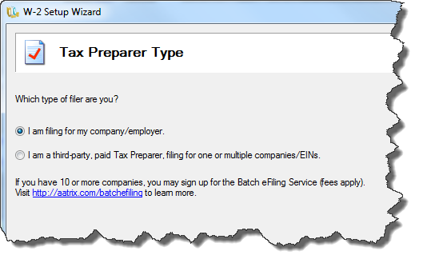
Unless you are a CPA or Tax service doing returns for someone else you should choose “I am filing for my company/employer.”

State and Local Tax Items
After confirming your company information, you will have the option to add columns to your W2. Columns can be added for State and Local Tax items. For instructions on how to do this see Section 7: Adding State and Local Tax Items.

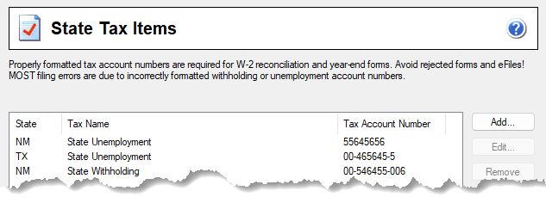
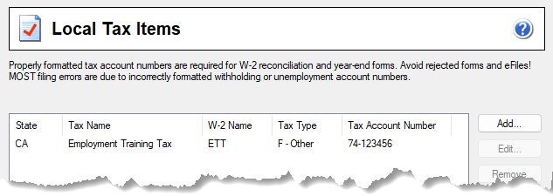

Data Verification

This screen asks questions that allow the system to effectively verify your data based on your filing needs. In most cases you should say NO to the questions unless you have employees who meet one of the listed conditions.

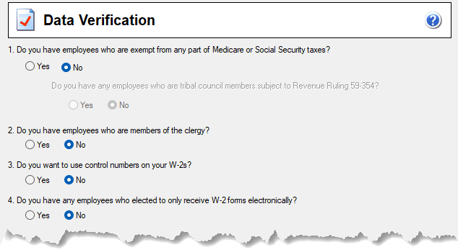

One exception common to Governments, Indian Tribes and Non-profit organizations is the first question:

“Do you have any employees who are exempt from any part of Medicare or Social Security taxes?”

This means do you have an earnings code that is subject to MC or SS Taxes but not both (one or the other). In short:

-Do you have earnings that are subject to Medicare but not Social Security?
-Do you have earnings that are subject to Social Security but not Medicare?

If you say yes to this question this will change some of the validations on the Aatrix grid. This will also enable you to check yes to the question “Do you have any employees who are tribal council members subject to Revenue Ruling 59-354?” If this is checked, you will have the ability to put items Box 14 in compliance with Revenue Ruling 59-354 that deals with Tribal Council Pay. KB about it is at https://kb.communitybrands.com/article/tribal-council-pay-and-box-14-and-r-59-354

W-3 Information Screen
Next you will be prompted to enter the information that goes on your W3. Some of this information may already be in the System from the values entered in Organization>Organization Information>Electronic Filing. This information is also availible to be edited once you are in the actual grid.

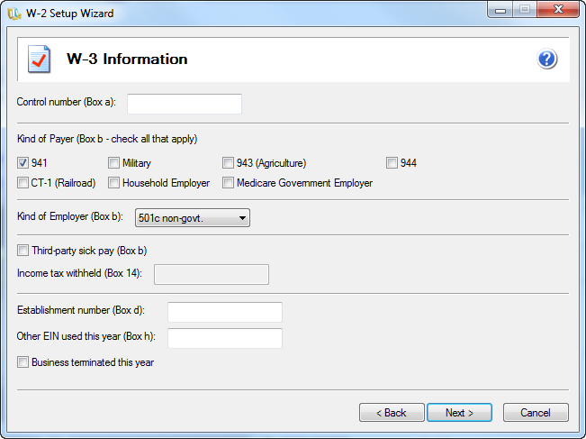

You will be asked if you want to truncate Employee Social Security Numbers on printed Employee copies. This is optional

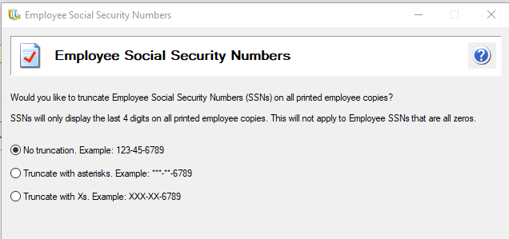

A reminder message will come up to verify the amounts in the W2 boxes with a W2 Information report from MIP FUND ACCOUNTING. For information on how to run this report please see KB 6166. This message may be hidden behind the screen and you need to move MIP to find it.
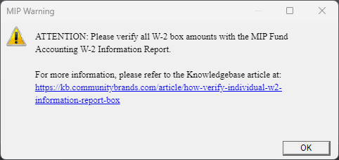

Section 2 – The W2 Preparer Grid

The W2 Preparer Grid

The next section of the W2 process is the W2 Preparer grid. You will use this grid to edit and verify your W2 information.
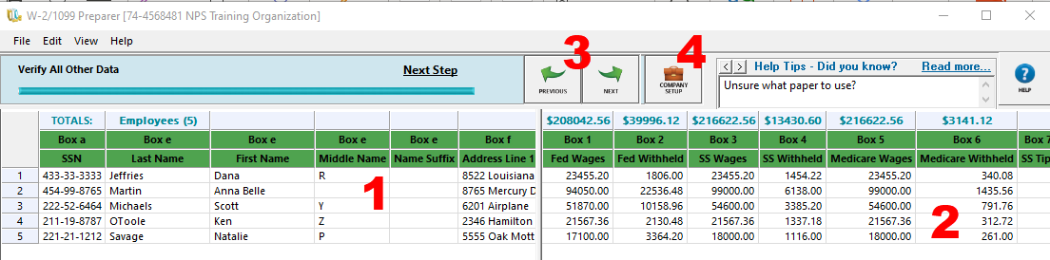

1 Employee Information Window
Use this section to verify employee name, address, SSN etc.

2. W2 Box Number Window
This display amounts of W2 Box Numbers. Use this to verify W2 amounts. There is a column total at the top.

3. Next Step
Use this to move through the validation process. You can go back.

4. Company Setup.
If you need to run through the previous wizard to change Local Tax Account Codes, Company Address or Filter Type information click this button.

After verifying all information in the grid, click next to move on. If you try and click next when some information is missing or incorrect you will receive a validation error message. In addition to the message the cell that has the problem will be highlighted in red.

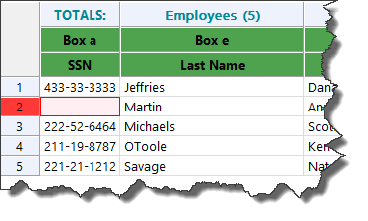

This problem must be corrected prior to moving to the next step.

Making corrections
You can make corrections through MIP FUND ACCOUNTING or within the Aatrix® preparer grid.

Correcting the Error through MIP FUND ACCOUNTING:

To correct the error through MIP FUND ACCOUNTING you will need to exit out of the W2 process making sure not to save any changes.

Once out of the W2 process you will need to go into MIP FUND ACCOUNTING to make the appropriate corrections.

For corrections to basic employee information such as name and address go to Maintain>Employee Information. Pull up the employee ID and make the necessary changes.

For corrections to W2 box information you must adjust in payroll. If you are changing amounts in W2 Boxes 1-6 this is usually done by going to Activities>Payroll>Setup/Adjust Employee Balances. Adjustments must be made on the TAXES tab. Adjustments made on other tabs will not flow onto the W2. For detailed instructions see Section 10: Auditing and Correcting W2s.

After you have made the necessary changes in MIP FUND ACCOUNTING, start the W2 process over again. This ensures that Aatrix® will process the changes you have made. After you get back to the preparer grid you will want to make sure the changes are there.

Correcting the error through Aatrix®:
Rather than exiting the Aatrix® process and making changes in MIP FUND ACCOUNTING it is possible to simply correct the values directly on the Aatrix® grid. Simply edit the cells within the grid. You can use the tab key to automatically move between cells with error messages.
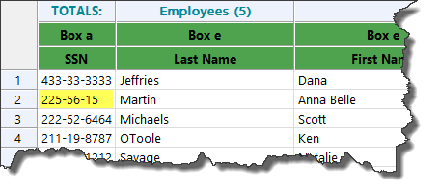
After you have made the correction, you can click next and move onto the next validation. The disadvantage of this method is that changes made directly on the grid will not update MIP FUND ACCOUNTING Payroll. If you create a new W2 file, the changes you made will not be present in the new file.

You can copy/paste, add new columns, and manipulate data within the grid. See Section 9 - Advanced Grid Operations.

Section 3 - Filing and Printing

After verifying your W2 information you will be able to select what options you want for eFiling and printing.

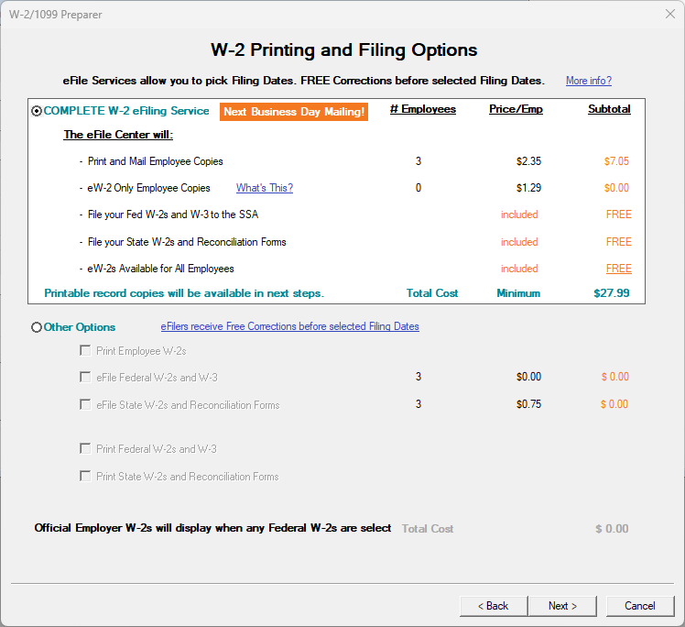

Complete W2 eFiling.
The cost is $2.35 per employee with a $27.99 minimum charge (prices subject to change). If you select this option Aatrix® will electronically file your State and Federal W2s as well as print and mail your W2s to your recipients. With this option is it also possible to post W2s to a secure website in addition to having them printed and mailed. Employees can access this website for additional copies if needed. You will also have the option to print a paper copy if you desire. You should complete your filing and have it submitted to Aatrix® by Jan 29th at 3pm CST ensure timely delivery of your W2 Filing.

NOTE: There is a promotional discount on the Complete eFiling Solution. If you use this option and file between Dec 20, 2024 and Jan 12, 2025 there is a discount per employee with the same minimum.

If you elect the complete filing option for W2’s AND 1095-C you will be get a combined price of around $3/Employee. To get this combined filing, you would produce your W2’s with the complete filing option. When entering information on the Aatrix efile site you will be asked when you would like to have your filing submitted for processing. Choose the last period available.

Later, when you produce your 1095 forms, choose the complete filing option. It should automatically detect your pending W2 process and will ask if you want to combine them. If your W2 filing has already been processed this discount will not be available.

eW-2 Only Employee Copies
This is an additional option to the Complete W2 eFiling. Instead of having Aatrix® print and mail the W2s they will post them to a secure website that employees can access with a unique password. The cost for this is $1.29/employee. It is an additional option of the Complete W2 eFiling Package. Not all employees have to participate in this. If you select this option only the employees who have opted to receive the eW2 will be included. The rest will receive their W2s in the mail from Aatrix® as part of the Complete Filing package.

For detailed instructions on the Express eW2 Filing option see Section 8- Electronic Distribution of W2’s.

eFile Federal W2 & W3
Aatrix® will file your Federal W2’s at no charge. You still may have to complete payment information in the process but your credit card will not be charged. You will also have the option to print the Employee, Federal, State and employer copies of your W2’s. Be sure to purchase the appropriate forms for printing your own copies. See Section 5 - Required Forms.

eFile State W2 and Reconciliation Forms
The cost is $.75 per employee with a $27.99 minimum charge. Aatrix® will file your State W2s for you. You will have the option of printing the Employee, Federal, State and employer copies of your W2’s. Be sure to purchase the appropriate forms for printing your own copies. (See section 5).

eFile Local W2-W3
If you have any Local W2 information it may be possible to eFile Local W2/W3’s you will see this option further in the process.

Printing Options
You will have the option of printing the Employee, Federal, State and employer copies of your W2’s. Be sure to purchase the appropriate forms for printing your own copies. See Section 5 - Required Forms.

For the purposes of this example we will use an eFile example for Federal forms and print the Employee W2’s.

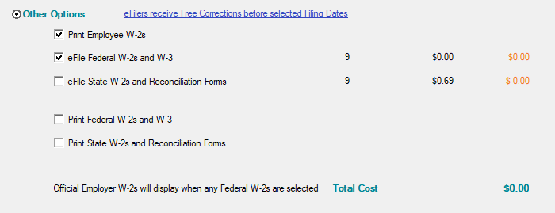

You will then get a summary of what is going to be printed out. You can print this list if you like.

NOTE: Clicking Print here does NOT print your W2s. Only a list of what is going to print.

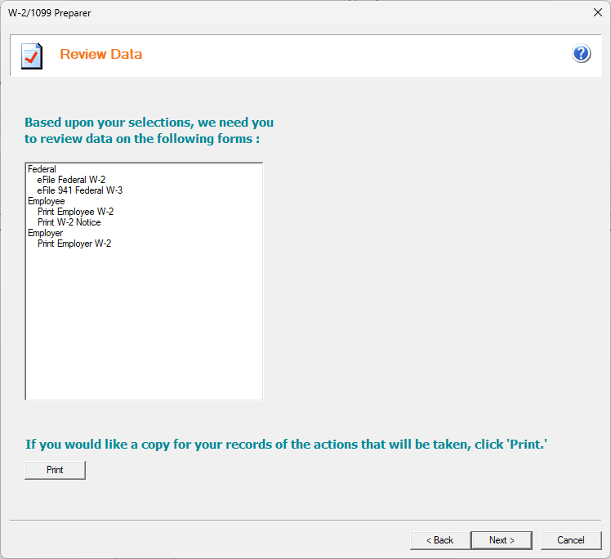

After clicking Next the W2 Form Viewer screen will come up.

Section 4 - W2 Form Viewer

The W2 Form viewer is the final step before printing and filing. It gives you the opportunity to see what the form will look like when printed/filed. In this case it is the Employer Copy of the W2s that will be eFiled.

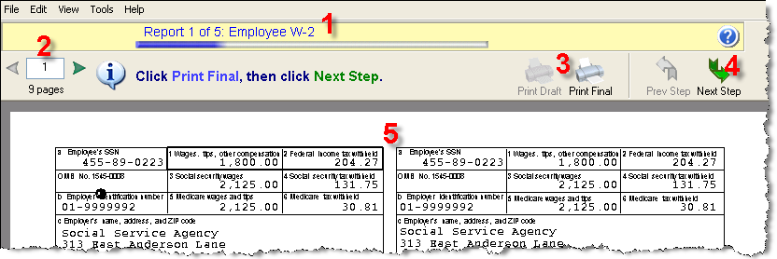

1. Form Record
This section lets you know what form you are looking at. As you move between forms (ie W2 Employer Copy vs W2 Employee Copy) you will see the progress bar advance.

2- Page Record on the Form
This shows you which page of the current form you are on. It lets you select which page you want to view.

3. Print Buttons
Print Draft will print a watermarked copy that cannot be used for filing while Print Final will print the actual form for filing. NOTE: “Print Final” can be selected multiple times. For example, if you want three copies of a document, simply click “Print Final” three times before proceeding to the Next Step.

NOTE: If you have selected to efile, certain forms may only have print draft available. This is to avoid accidental duplicate filings.

4- Next Step
Once you have completed reviewing and printing these forms click this to move on to the next form in your list. For W2 filing the Previous Step button is disabled. If you have to go back to an earlier form you will need to start the process over again.

After you have clicked Next Step on the first form it will take you to the next form on your list as well as asking if you would like to print the final copy of the form. Once you have advanced to the next form you cannot go back to a previous form without restarting the process. Look in the Form record section (pictured in yellow) to see what type it is. In this case, it is the Employer W2.

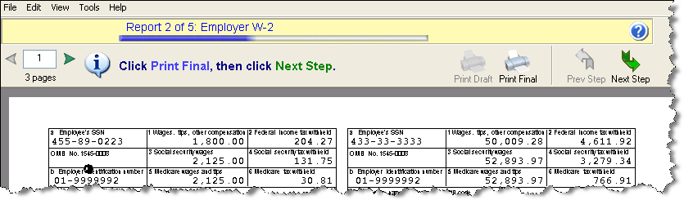

Clicking the Next Step button will bring the next form and so on.
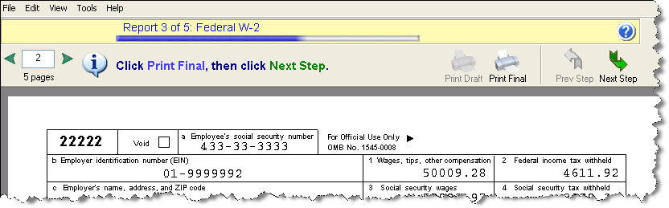

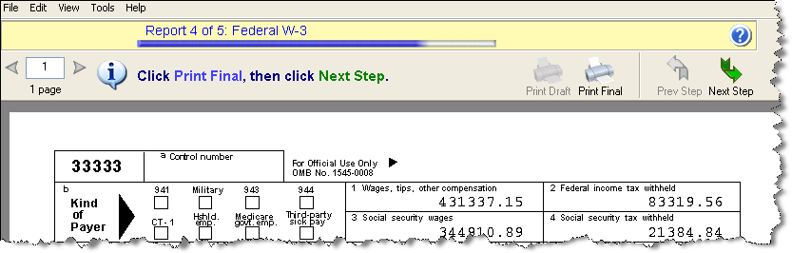

The final Page is the Employee Instructions. If you do not have forms with these instructions printed on the back you can print them out now and distribute them to your employees.
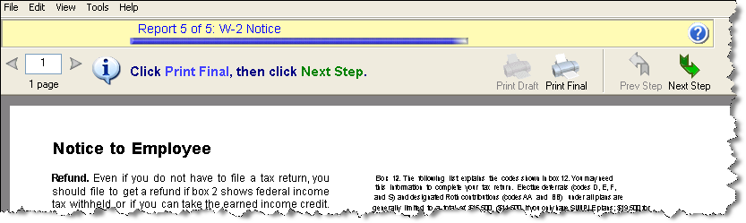

eFiling
After you have done all of your printing, if you selected to do any eFiling you will be prompted to Log into the Aatrix® Website.
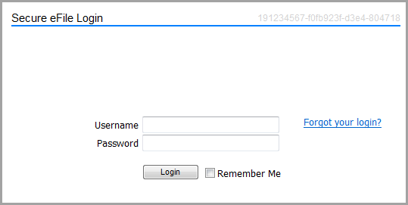

Use your Aatrix® username and password, not your MIP Fund Accounting username and password. If your organization’s FIEN # has already been registered with Aatrix® and you do not know your user name or password contact the person who registered. If they are not available contact Aatrix® directly for your options. They can be reached at helpme@aatrix.com or 1-701-746-6814,

If this is your first time using Aatrix® or your organization does not have an account click the Forgot your Login? Link followed by the Enroll Link on the page that loads. To complete your enrollment you will need to have your organization’s information, a credit card number. You will need to print then send in an authorization form before anything can be filed through Aatrix®. (This includes free Federal filings)

After you have eFiled you can exit out of the process or do more processing. For instructions on additional processing or to do corrections see Section 6.

Section 5 - Required Forms

NOTE: W2’s, 1095-C’s and 1099’s will be done through Aatrix®. You may wish to order your 1099 or 1095-C forms when you order your W2’s. For more information on how to do 1099’s through Aatrix® see KB 12806. For information on 1095-C forms see the required section of KB 13801.

MIP FUND ACCOUNTING Fund Accounting includes the “Tax Forms and eFiling by Aatrix®” functionality for Payroll tax forms. This new feature eliminates the need for some or all pre-printed forms-allowing you to eFile or print your tax forms on plain paper instead. If you chose to print forms note the requirements.

Form Requirements for W2

-The Employee copy of the W2 should be printed on the blank 4 part perforated paper.
-The State copy (if any) should be printed on the blank 4 part perforated paper.
-The Employee Notice is printed on the back of the 4 part perforated forms or it can be printed separately on plain copier paper

Note: As of Tax year 2023 if you have more than 10 forms you must efile the Federal copy
-The Federal copy of the W2 can be printed on plain copier paper, no forms needed.
-The Federal copy of the W3 can be printed on plain copier paper, no forms needed.
-The Employer copy of the W2 can be printed on plain copier paper, no forms needed

Below list for the form numbers for MIP Checks and Forms.
To Order call 1-844-857-2898 or log on to:

https://www.mipchecks.com/estore/TAX-FORMS/W-2s/cat1820039_ctgy.c?networkId=MIP

Only the below part numbers are compatible with MIP FUND ACCOUNTING.

W-2 Forms
W-2 Laser – Form Only – One employee per page
LW2BLANK4

Bundle W-2 Laser Package Set – Forms and matching envelopes.
LW2BK4DWS

W-2 Forms have the following features:
• IRS-Required Plain Perforated Paper
• Laser W-2 for use with Laser or Inkjet printers.
• Each 8 1/2” x 11” sheet is perforated according to IRS regulations
• Fully compliant with IRS Publication 1141
• Employee filing instructions already printed on the back to save you time and money
• Form only option also available upon request.
• Free W-3 Transmittal form with every W-2 order.

Question-If I have forms left over from last year can I use them?

Answer-The blank perforated stock does not change from year to year. Any unused stock from last year can be used this year. Pre-printed forms are year specific and cannot be reused.

Section 6 - Corrections, W2C’s and Additional filings

There are two ways to start working with your W2 History. You would do this if you want to do a correction, W2C, reprinting or additional filing.

Go to History
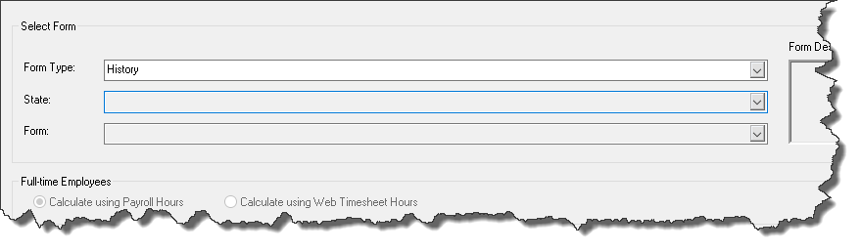
Down at the bottom of the screen Click OK.
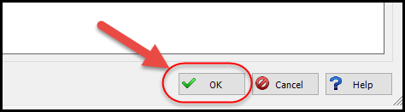

This will bring up a screen that shows ALL histories.
Choose the History File that you wish to work with and click EDIT.
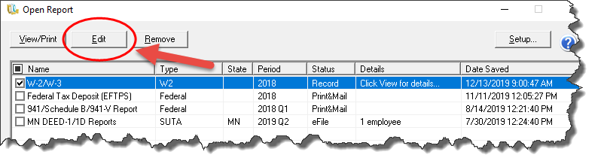
NOTE: In most cases you want the file that says “Record” as the status. Choose the wrong file and result in your existing filing being overwritten with incorrect information.

After you have selected the correct history, this screen will come up.

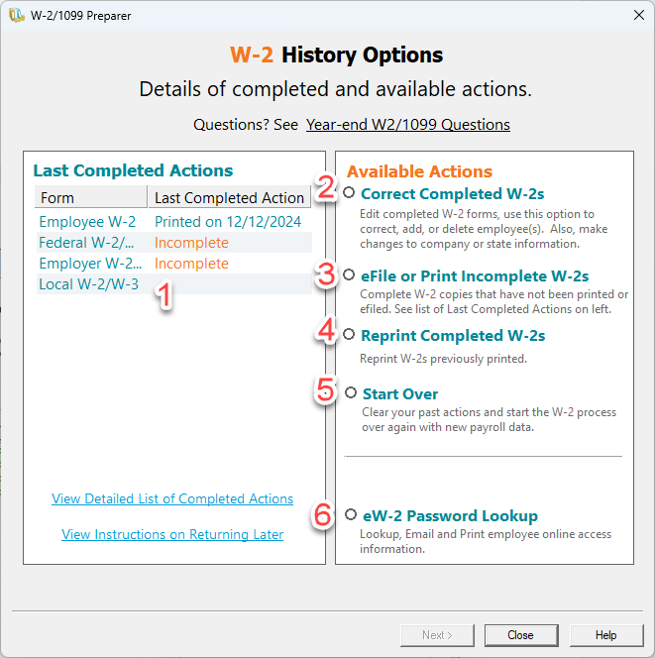

1 – This is a list of the current status of your filing. If you do not see your filing here it means it was not done or not completed to the point of being finished.

2- Correct Completed W2s
You will use this option if you need to make a correction to a W2 that has already been distributed or filed. For example, you print and e-file your W2’s and then an employee points out a mistake. You would not use this option to produce a W2 that was missed or skipped.

3- Process Non-Filed W2 Copies
You would use this action if you have not fully completed your W2 filing. For example, you may have printed the employee copies but not e-filed. Or you may have filed the federal copies but not the state copies.

4 – Reprint Completed W2s
You would use this action to reprint any copy of the W2 that has been taken to completion (either through printing, filing or e-filing). This is the option you would use to replace a lost W2 or give an employee an additional copy.

5 – Start Over
This option will delete your previous W2’s and start over again. You will lose any changes or modifications you have made to the W2’s in the Aatrix® grid and the data will be pulled from MIP FUND ACCOUNTING. If you have eFiled this option will not be available. Use Correct Completed instead.

6 – eW2 Password Lookup
After you have filed W2’s using the express filing or complete filing methods this option will be available to look up the employee’s password for their eW2’s.

How to Process Additional New Filings
If you did not do all your filings the first time (for example you skipped your Employee filing) you have the option to go back and do them. To do this you would choose Option 4 – Process
Non-Filed W2 copies.

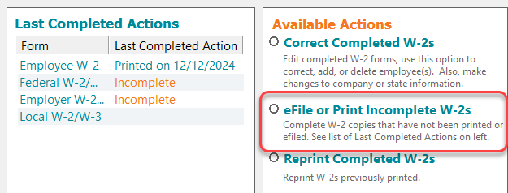

In this example notice that the check box for “Print Federal W2s and W3” is grayed out because of past actions.

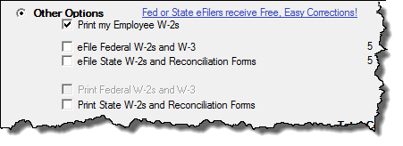

After selecting that, you will be asked a few questions in the Wizard and then you will get the screen showing what actions will be taken.
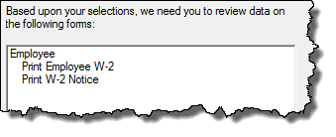

You will get the form viewer screen with the forms selected to print. After successfully printing all the forms you will see that your actions have been updated.
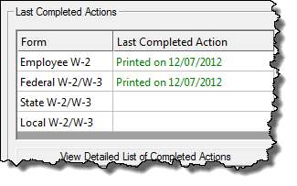

How to Reprint Completed W2s
After printing once, if you need to reprint a W2, you can do that from the W-2 History File Options. You select the Reprint Completed W-2s action.
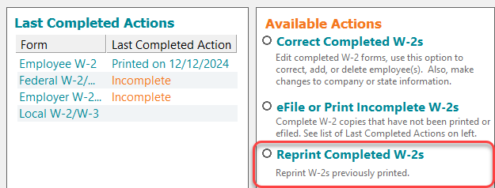
If you select this, you will get the Reprint Options screen. This will let you select from your already printed forms which ones you wish to reprint.

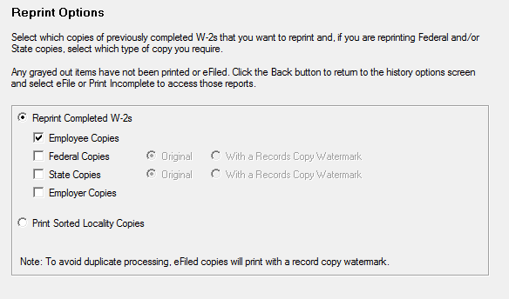

If you select Federal or State Copies the box at the bottom asking if you want to reprint Original or Record copies becomes active. Original Copies can be used to file taxes with the government. Record Copies will have a “Record Copy: Do Note File” watermarked on them.

After selecting the copies, you wish to print the Reprint Employee Options Screen Comes up.

NOTE: If you have used the complete filing option reprints will be watermarked record copy. If you have eFiled the Federal Copies will be watermarked.

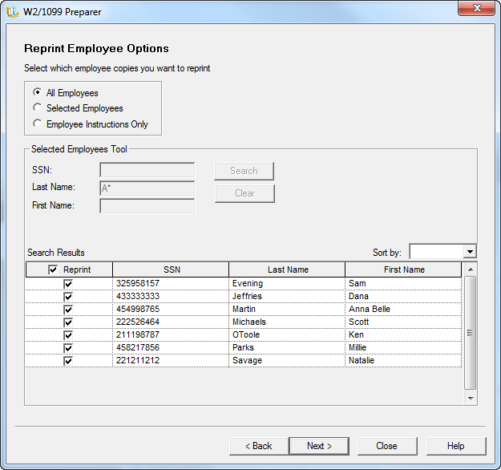

This screen gives you the option to reprint all or a select group of employees. If you choose selected employees, you can filter and sort on employee information and select the employees you need to do the reprints for.

After Clicking “Next” it will take you straight into the form viewer window. You can make your reprints directly from this window.

Reprints will not update your last action but will show up in your View All Completed Actions.

Correcting W2s
If you have already printed and filed your W2’s and need to do a correction you will choose the “Correct Completed W2’s” option.

This will bring up the Correction Options asking if you have distributed any copies. If any copies have been given to the Employee or Filed to the Government (mailed or Efiled) you should check the boxes.

If you have eFiled or used the complete filing option the system may restrict your options based on the status of your eFile in Aatrix®.
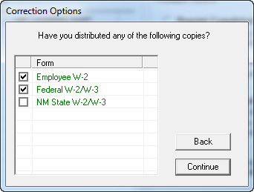

Selecting this option will take you back into the Aatrix® Grid which will show your W2 History. You should make the necessary changes to your W2 Information.

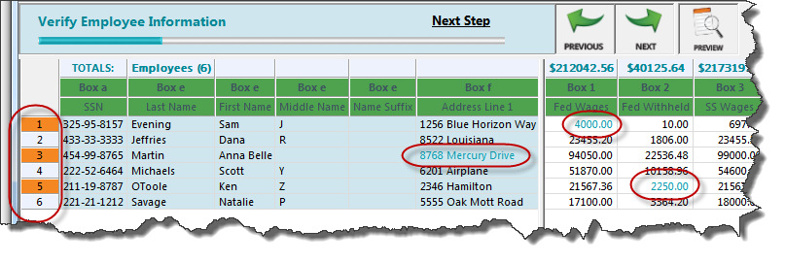
Anytime you make a correction the field corrected will change color and the row number that field is located on will become highlighted as well.

WARNING- Do not delete any employees from this grid unless they were not supposed to be issued a W2. Deleting employees from this grid will result in their W2 record being removed, even if you have already eFiled.

After all the changes have been made and the data has all been verified if there were state corrections required you will be asked to verify that.

W2C
When you go to print your corrected filings you may either get a W2C or a replacement W2.
It depends on if your W2’s have been sent to the government or eFiled. If your Filing has been mailed or electronically filed you will get a W2C, otherwise you will get a replacement W2.

Even if you have eFiled you may still get a replacement W2 because Aatrix® has not submitted your eFile to the Federal Government.

Depending on the forms chosen and the type of corrections made Aatrix® may print some or all employees after you have made a correction. If you do not want to print the entire range of employees that Aatrix® lists you can choose to print specific pages.

Starting Over
If you have significant problems with your W2 you may wish to simply start over. To Start over choose the Start Over action on the W-2 History File Options.

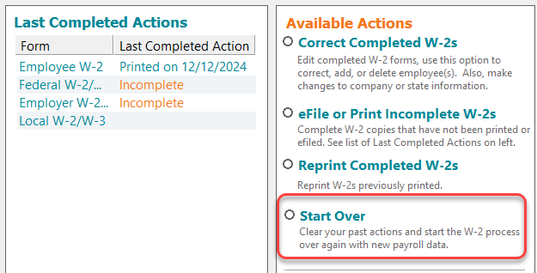

You will first be asked if you have distributed any copies. This means that you have either handed them out or filed them.

If copies have been distributed, then you cannot Start Over. Instead, you must go to Correct Completed.

If you say NO then it will take you back through the W2 Wizard.
The grid will be refreshed and new information will be pulled in.
Any previous edits, deletions or changes that you made in the Aatrix® grid will be lost.

If you have eFiled Start Over will not be available. If you wish to start over you will need to log onto the Aatrix® website and delete your filing for start over to be available. If any portion of your filing (Federal or State) has already been submitted, you will not be able to delete it. If you need to start over at this point you will need to contact Aatrix® for assistance.

Section 7 - Adding State and Localities to your W2

Aatrix® directly supports printing forms for many states as well as a few select localities. If you have information for an Employee’s state withholding already recorded in payroll, it will automatically be pulled into Aatrix® and you will see it identified in the preparer grid.

If the taxes were recorded in MIP but are not coming into the Aatrix grid they may not be set up to do so. Go to Maintain>Payroll>Other Taxes. Pull the Tax up.
On the line that says Aatrix tax type click the find button.

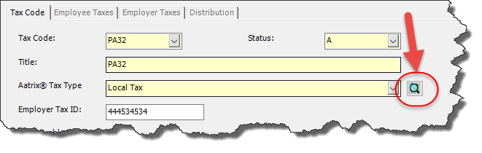
In the filter choose your state (1) and then the Display records button (2). This will let you select a supported Tax type (3).

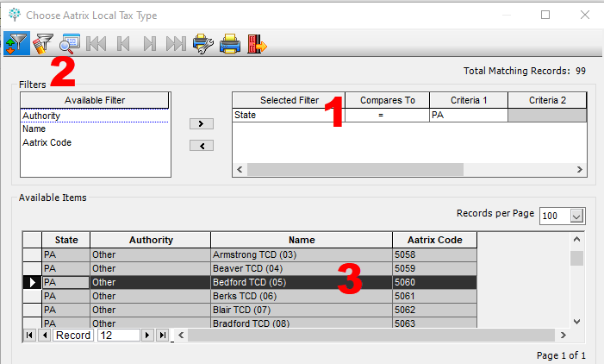

The next time you pull Aatrix in any tax information with that code will go to the appropriate column.

If you don’t have that information, or you need to record some type of information that is not recorded in MIP FUND ACCOUNTING, you have the option of manually creating that column in the W2 and then manually adding the values.

In the W2 Setup Wizard there is a screen for adding State and Local Tax Items. If you have already gone past this point you can always go to Edit>Update Company Information to get back to the wizard.

If you click on add it will let you create the tax. There are many pre-defined taxes for states and some localities.

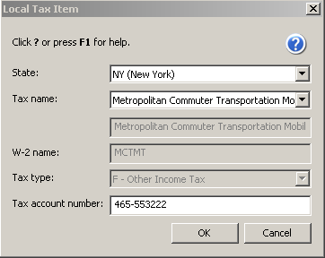

If you do not see the tax you are looking for it will need to be created.

To create a new tax, you must first select the State that the Tax resides in, even if it is a local tax (what state is the locality in)

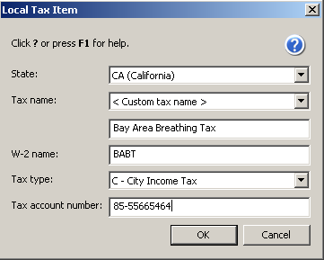

There are different Tax Types that can be designated. They are City, County, School District and Other Income Tax.

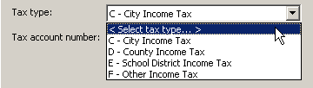

After you have added the Tax(es) you should see them in the screen to use.

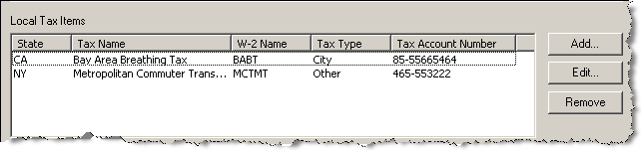

After the columns have been added continue with the W2 process as normal until you get to the preparer grid. On the preparer grid you see the columns that you have added.

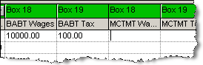

If you do not see the column that you added, it is because the value that you gave it in the Tax Name portion of your setup is not a field that can show on the W2.

You will notice that there are no values for these taxes in the preparer grid. You will need to manually type the values in. To manually add in values, click on the cell that you wish to type in a value. You may be able to type the value directly into the cell or it may bring up an edit box.

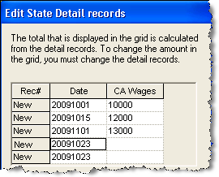

Some values that you put in (usually State Wages and Taxes) must have a date associated with them. The edit box allows you to enter the wages in with as much detail as you wish. The Date column is the date that those wages were paid. You can break the wages out into the actual dates they were paid or lump them together at the end of the year depending on your reporting needs. The date format in the date column is YYYYMMDD.

Other values (usually Local wages and taxes) may not require a date. The values can be directly typed into the cell. When you are done the values should appear in the grid.
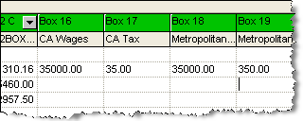

These values will carry forward to your W2 printouts and filings.

NOTE: Any information entered through this method WILL NOT update the values in MIP FUND ACCOUNTING. It will only show up in Aatrix®.

Section 8 – Electronic Distribution of W2

The ability to distribute your W2’s electronically is an option as part of the Complete Filing Solution. If you wish to use electronic distribution you have two options.

One is to distribute electronic W2’s in addition to the regular complete filing solution. You pay for the complete filing solution and in addition to Aatrix® printing and mailing the Employee copy the information will be available for download off of a website.

The other option is to distribute electronic W2’s ONLY. This decision is made on an employee by employee basis. Selected employees will not receive a paper W2 in the mail. Their information will be available for download on a website. Using this option reduces the cost of filing from over $2.35 to $1.29 for each employee selected. This selection process is made in the Aatrix® grid.

NOTE: The electronic distribution of W2’s requires putting in your SMTP information into the Aatrix eFile website and making sure your SMTP server security is properly configured to allow the connection. Assistance with this is beyond the scope of MIP support.

For the most efficient processing there are several steps you should take prior to running your W2’s.

First go to Organization>Organization Information and select the electronic filing tab. You should fill in the information requested.
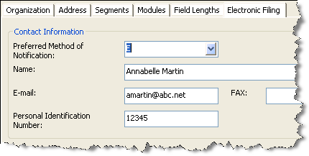

Prior to doing electronic W2’s you are supposed to receive a signed consent form for each employee. You can print a copy of this form by going into Activities>Payroll>Tax Forms and E-Filing by Aatrix® and selecting the Electronic W2 Consent form to print.

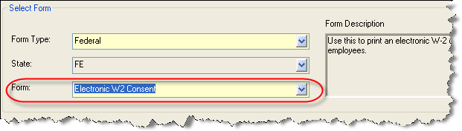

After you have received the forms you should go to Maintain>Payroll>Employee Information and pull up each of the employees that have elected to receive an eW2. On the W2 tab there is a place to put in the Electronic Employee W-2 Information. You should fill this information in.

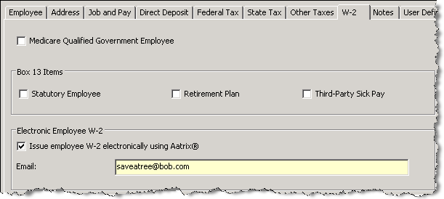

After you have updated the employee information it will automatically pull into Aatrix®.
If you don’t put this information in you will have another chance to add it to the Aatrix® grid.

Once in the Grid you will be able to see and modify the electronic W2 information.

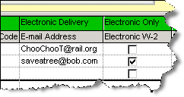

If you have selected the complete filing option then every employee who has an email address will have the option of retrieving their W2 electronically as well as receiving the mailed copy and you will be charged $2.35 for that employee.

Employees who have the Electronic W-2 only box checked will only be given an electronic copy, no paper copy will be mailed, and you will only be charged $1.29 for that employee vs. $2.35.

If you do not have the employee email address at the time, you can still print out an access letter for the employee to use to retrieve their W2 information and add their email address in the W2 Password Lookup Tool (see above, Section 6, Field 6 of this guide) and email them the notification at that time.

After you have confirmed the electronic W2 information in the grid, then go to select the complete filing option, you will see the price difference if any employees were selected for electronic W2’s only.

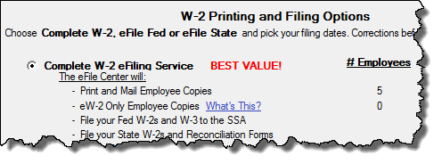

Section 9 - Advanced Grid Operations

The W2 Preparer grid has many data manipulation options built into it. These can be accessed through the various menus or by right clicking on the column headers.

The Edit Menu provides the most functionality. Like an Excel spreadsheet you can sort, cut, copy and paste information to and from the grid.

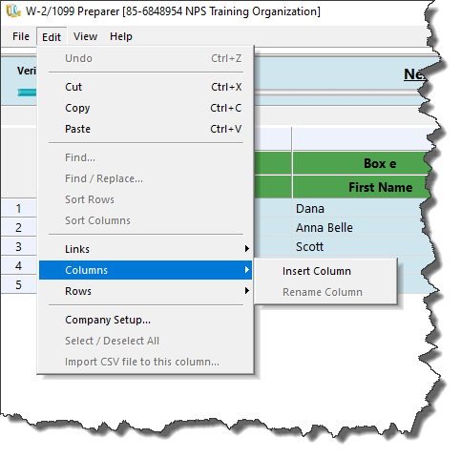

Copy/Paste
The Aatrix® grid has copy and paste functionality built into it. You can select an entire row or an entire column to copy or paste. Select the Row or Column header like you would in a spreadsheet and go to Edit>Copy or CTRL+C. You can then paste this into your spreadsheet. The inverse can be done as well. Copy a range of cells from your spreadsheet and paste them into Aatrix® a column or row at a time. Due to limitations of the Aatrix® program it is not possible to copy or paste multiple columns at the same time. You can only copy one row or one column at a time.

Update Company Information
If you need to make changes to your company information (Address, State and Local Tax Items, 941 information, third party sick pay etc) you can do so in the Aatrix® grid by going to Edit>Company Setup or Click on the Company Setup Button. This will bring up the initial company information Wizard and let you make changes.

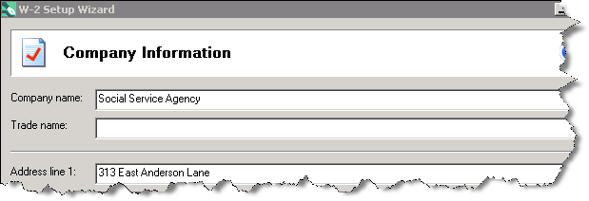

Sorting
Aatrix® provides the ability to sort on any column in the grid. To sort on a column RIGHT CLICK on the column in question you will see a sorting option on the dropdown menu.

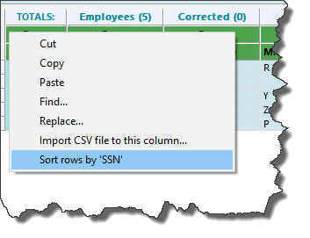

Other Column Functions
In addition to sorting there are many other options you can do with each column as you can see in the menu.

You can move the columns to the left or right. You can Cut or Copy information. You can also Find or Find and Replace.
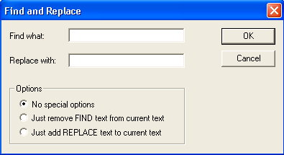

Inserting a Row
Another useful command in the edit menu is the Rows>Insert. If you need to add a new record to your W2’s you can insert a line into the grid and then manually add the record by typing in all the information. You can also insert a row by selecting the Row by right clicking and choose Insert.

Deleting a Range of Rows
While you cannot copy a range of rows it is possible to delete a range of rows. This can be useful after you have sorted rows for records you do not want. You can use the SHIFT + Click to select a range of contiguous rows or the CTRL + Click to select multiple non-contiguous rows.

Run W2 Notification Wizard
This option on the file menu activates the Aatrix® Password deliver wizard in order to distribute eW2 password notifications. It is the same process as if you were going through the Aatrix® Password Wizard the first time. For detailed instructions see Section 8.

Section 10: Auditing and Correcting Your W2’s

If you are uncertain about the origin of the values that have been pulled into the Aatrix® grid you can check those values by running a W2 information report (Reports>Payroll>Payroll Tax Worksheets). To do that:

NOTE: You must Calculate W2 Information for the current tax year before this report will work.

- Go to Reports>Payroll >Payroll Tax Worksheets>Calculate W-2 Information.
- Select all employees for this tax year.
- Click on Start to calculate.
- Go to Reports>Payroll>Payroll Tax Worksheets>W-2 Information.
- Select the <W-2 Box Information> Report.
- Go to the Filter tab and select the W-2 Year = 2024.
- Go to the Content tab and add “Employee ID” to the Report Body.
- Choose to “Show Total” for the Employee ID (this will help organize the data).
- Stay on the Content tab and add all appropriate W2 Box numbers that pertain to YOUR organization.
- Go back to the Setup tab and hand key a new and unique Report Name.
- Run the report (to printer or screen).
- Use the MIP FUND ACCOUNTING W-2 Information report to compare values with the Aatrix® W2 preparer grid.

If you find values in the Aatrix® W2 preparer grid that do not match the values on the MIP FUND ACCOUNTING W-2 Information report then you can manually change the numerical value on the Aatrix® grid to match the report.

NOTE: Any changes made within the Aatrix® W2 preparer grid will not affect the MIP FUND ACCOUNTING database.

If the numbers do match, but you believe the value in the MIP FUND ACCOUNTING W2 information report to be incorrect, you can get a detailed analysis of the contents by running the Payroll Tax History Reports.

Auditing Boxes 1-6
To get a detailed listing of the values that were pulled into Boxes 1-6, go to Reports>Payroll History>Taxes. There is a default report <W2 Detailed Audit Report> to use as a basis for your research. This will produce a detailed listing of all transactions that have affected your tax amounts. You may wish to go to the filter tab to restrict the information to a specific type of tax. The most common cause of incorrect values in these boxes are:

1 – Some type of Earnings, Benefit or Deduction code was improperly set up on the Taxes tab of that code. As a result, it improperly affected taxes (making them too much or too little).
2- An adjustment was done to the employee information, but the Taxes tab of the adjustment was not correct. Usually earnings, benefits and deductions were entered on the adjustment, but nothing was done in the taxes. As a result, the taxes are off by the amount of that payroll.

Correcting Amounts in Boxes 1-6
To correct the values in Boxes 1-6, go to Activities>Payroll>Setup Adjust Employee Balances. Select the employee ID, create and adjustment number and give it an adjustment date (usually 12/31 if you are making one adjustment for the whole year). On the Taxes tab you would select and adjust the various taxes that are incorrect.

When making the adjustment, be sure to adjust both Subject and Gross Taxable earnings together. The amount of the adjustment is the difference between the current value and what you want it to be. Therefore, if your current value for a particular tax was $900 and it needed to be $950 you would do a +$50 adjustment. Alternately you can just adjust the amounts in the Aatrix® grid. This is discussed in Section 2.

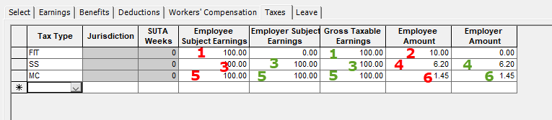

The numbers here represent what box number the adjustment is associated with (1-6).
Numbers in RED are the boxes that directly affect the values in Aatrix.
Numbers in GREEN are normally associated with adjustment to that value but adjustents in those boxes will not actually change the value on the aatrix grid.

Auditing Boxes 15-20
The same <W2 Detailed Audit Report> also is useful for auditing your boxes 15-20. However, because of the limitations of the MIP FUND ACCOUNTING system and the varied requirements for the contents of Boxes 15-20 it is common to have amounts that are not correct. If this is the case, you can correct the amounts in these boxes by using the same method for Boxes 1-6 but adjusting State/Local/Other Taxes. If for some reason it is not possible or to complex to adjust these boxes in MIP you can correct those amounts in the Aatrix® W2 preparer grid mentioned in Section 2.

Auditing Boxes 12 and 14
These boxes are a little more difficult to audit. The reason being is that they often pull from multiple sources and there is no one easy report that is guaranteed to pull them all. Amounts in Box 12 can come from Earning, Benefit and Deduction codes. Most of the time discrepancies are because Benefit codes or deduction codes are not set up as being subject to Box 12. In most cases, only Benefit Codes should be flagged as being subject to Box 12.

To investigate those codes you should go to Payroll>Reports>History>(Benefits or Deductions). There is a detailed default report that can be used to start with.

Correcting Amounts in Boxes 12 and 14

Unlike other boxes, by adding or removing a W2 box number to a earning, benefit or deduction code, the Aatrix® grid will add or remove all information associated with that code from the W2 box number. So, if you discovered your Box 12 information was off by the amount associated with a certain benefit code, go into Maintain>Benefit codes and remove Box 12 (select W2 Box Blank) from the W2 information. Recalculate your W2’s. The amounts from this code will no longer contribute to Box 12.
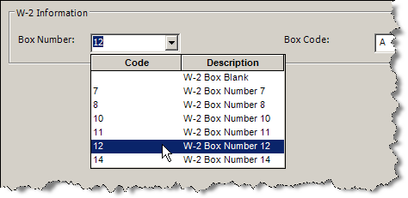

To get a list of which codes affect what W2 box you can go to Reports>Payroll>Lists and see listing of the different types of codes. In the content tab of the report, there are fields called W2 Box Number and W2 Box Code. Add those to your report body to see what is currently affecting your W2’s.

Remember if you make any changes you should recalculate both your W2 Information report and the W2’s in Aatrix® or the changes will not take effect.

Alternately you can just adjust the amounts in the Aatrix® grid. This is discussed in Section 2.

Health Insurance Reporting Requirements
The Patient Protection and Affordable Care Act of 2010 (Obamacare) requires that you report the cost of group coverage health care on the employees W2, specifically in box 12 DD. To do this you would mark the Benefit AND Deduction Codes used for health insurance as subject to Box 12DD. This will net the two values in the W2.

Extra Medicare Taxes
Tax law states employees earning more than $200K will see Medicare wages taxed at a higher rate. All earnings under $200K are taxed at 1.45%. Any earnings above $200K are taxed at 2.35% regardless of filing status.

Form 1095-C
Some employers will be required to report additional information regarding health insurance. This is not a requirement on the W2’s, it will be reported on a separate form (1095-C).

